**Twitter Analytics Dashboard Report**

**Company:** Null Class

**Candidate:** Supriya Mourya

**Domain:** Data Analytics

**1. Introduction**

This report details the tasks completed to create a dynamic Twitter Analytics Dashboard for Null Class. The project focuses on providing visualizations that deliver actionable insights into Twitter engagement. By filtering tweets based on specific engagement metrics, content types, and time constraints, this dashboard aims to refine social media strategies. Each task utilizes Power BI’s data analysis and visualization capabilities, filtered to deliver customized insights under unique criteria.

**2. Objectives**

The main objectives of the project are to:

- Develop visualizations that identify high-performing tweets based on different engagement metrics.

- Enable stakeholders to make data-driven decisions by understanding which types of tweets drive more engagement.

- Implement filters to ensure data relevance and accuracy.

**3. Tasks and Visualizations**

**Task 1:** Engagement Rate and Total Impressions Visualization

**Objective:**

Create a visualization displaying the average engagement rate and total impressions for tweets posted between January 1, 2020, and June 30, 2020. This visualization only includes tweets with at least 100 impressions and zero likes. Additionally, it will only be visible between 3 PM and 5 PM IST.

**Process:**

- Data Filtering: Filtered tweets from the specified date range, excluded tweets with fewer than 100 impressions, and restricted to tweets with zero likes.

- Time Restriction: Configured the visualization to display only between 3 PM and 5 PM IST.

- Visualization: Used a line chart to track engagement rates over time, with a secondary axis displaying total impressions.

**Outcome:**

The visualization highlights specific time slots and engagement metrics, helping to identify trends in tweet performance across different times of the day.

**Task 2:** Clustered Bar Chart for Clicks by Tweet Category

**Objective:**

Develop a clustered bar chart showing the sum of URL clicks, user profile clicks, and hashtag clicks, grouped by tweet category (tweets with media, links, or hashtags). This chart only includes tweets that have at least one of these click types and is restricted to tweets posted between 3 PM and 6 PM on even-numbered dates, with word counts below 40.

**Process:**

- Data Filtering: Filtered tweets to include only those with URL clicks, profile clicks, or hashtag clicks, within the specified time, date, and word count constraints.

- Time and Date Restriction: Restricted chart visibility to tweets posted between 3 PM and 6 PM, on even-numbered dates.

- Visualization: Constructed a clustered bar chart to compare the interaction types across different tweet categories.

**Outcome:**

This chart enables stakeholders to analyse the types of tweets that drive different forms of engagement, supporting strategic decisions on tweet formats to maximize user interaction.

**Task 3:** Top 10 Tweets by Retweets and Likes

**Objective:**

Create a chart showcasing the top 10 tweets ranked by the combined count of retweets and likes, excluding tweets posted on weekends. This visualization includes the user profile associated with each tweet and is restricted to tweets posted between 3 PM and 6 PM on odd-numbered dates, with even impressions and a word count below 30.

**Process:**

- Data Filtering: Filtered out tweets posted on weekends and restricted to odd-numbered dates with even-numbered impressions and word counts below 30.

- User Profile Display: Configured the chart to display the user profile name alongside each tweet.

- Visualization: Built a bar chart to represent the top 10 tweets by engagement.

**Outcome:**

This chart offers insights into the most popular tweets, helping to understand content patterns and engagement behaviours. It also provides a user-centric view by associating tweets with the respective profiles, helping to identify influential users.

**Task 4:** Engagement Rate Comparison for Tweets with and without App Opens

**Objective:**

Analyse and compare the engagement rates of tweets with app opens against those without, focusing on tweets posted on weekdays between 9 AM and 5 PM. The visualization only appears between 12 PM and 6 PM for tweets with even impressions, odd-numbered dates, and word counts below 40.

**Process:**

- Data Filtering: Filtered data to include only weekday tweets with specified time, impression, date, and word count conditions.

- Time Restriction: Configured chart visibility between 12 PM and 6 PM for the selected criteria.

- Visualization: Created a comparative bar chart to display engagement rates for tweets with and without app opens.

**Outcome:**

This comparison provides a clear view of the impact of app opens on engagement, offering valuable insights for app-related content strategies.

**Task 5:** Dual-Axis Chart for Media Views and Media Engagements

**Objective:**

Build a dual-axis chart showing media views and engagements by the day of the week for the last quarter. The chart emphasizes days with high engagement spikes and only displays tweets with even impressions, odd-numbered dates, and word counts below 30.

**Process:**

- Data Filtering: Limited to tweets with the specified impression, date, and word count criteria.

- Visualization Design: Used a dual-axis chart to display both media views and engagements by the day of the week.

- Highlighted Spikes: Configured markers to highlight days with significant spikes in media interactions.

**Outcome:**

This visualization allows for targeted analysis of peak engagement days, helping to refine content release schedules based on audience activity patterns.

**4. Skills and Competencies Utilized**

The successful development of this dashboard required:

**Data Analysis:** Filtering large datasets by specific criteria.

**Power BI Visualization:** Designing dynamic charts with complex filters and time-based conditions.

**Data Interpretation:** Translating visual data into actionable insights.

**Problem-Solving**: Addressing challenges in data filtering and complex visualization requirements.

**5. Challenges and Solutions**

**Data Accuracy:** Ensuring data accuracy was critical, which required multiple validation checks.

**Complex Visualization Requirements:** Dual-axis charts and interactive features were configured carefully to balance clarity with detail.

**Time-Based Filtering:** Achieved by applying advanced time settings in Power BI, ensuring visibility only during specified times.

**6. Feedback and Outcomes**

**Feedback:**

The dashboard's interactive features were well-received, although users suggested adding additional functionality for drill-down options.

**Outcomes:**

**Enhanced Insights:** Provided detailed engagement metrics to improve content strategies.

**Improved Decision-Making:** Stakeholders gained a clearer understanding of which content drives engagement.

**7. Dashboard**

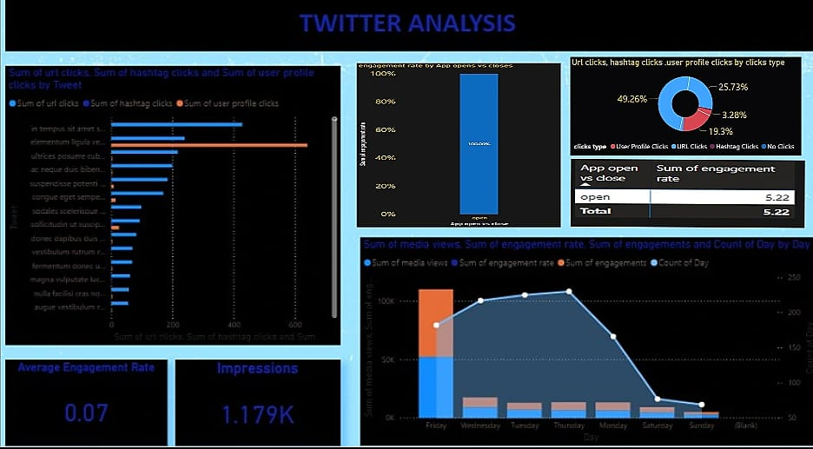

**8. Conclusion**

The Twitter Analytics Dashboard for Null Class successfully integrates advanced visualization techniques and robust data filtering. By delivering meaningful insights into engagement patterns, it enables stakeholders to make informed, data-driven decisions for social media strategies. This project demonstrates the importance of tailored analytics in optimizing Twitter performance and enhancing user engagement.